Lab 1 24k-2527
Task 1
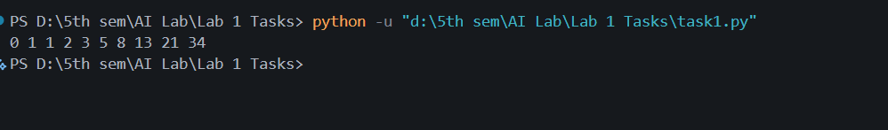
Task 2

Task 3
Task 4
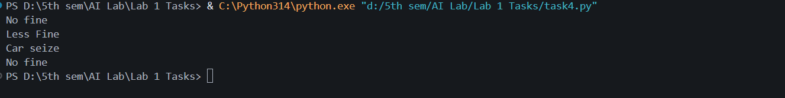
Task 5
Task 7
